OOPS PYTHON

1. Class:
2. Object
3. Reference variable:

**Class:** It is a blue print/template/plan/design of object is known as class it contains variables and methods (properties and actions)

**Object:** It is physical existence of class or instance of the class

In single class we will create multiple objects.

Note: Class and object is one to many relation ships

Ex1: Tv Model Design: Class

Each Tv : Object

Ex2: Ganapati Idol design or Mould (Atchu in telugu)

**Class** contain variables and methods/behaviour/functions and write some doc string with clear documentation of class and give some information about the class. Constructor method also there to initialize all variables inside a class it is fixed naming method def __init__(self) . Every object creation the constructor will created automatically

Types of variables: 1. Instance variable (Object level)

2.Static variable (Class Level)

3. Local Variable (Method level)

Types of methods: 1. Instance Method

2. Static method

3. Class method

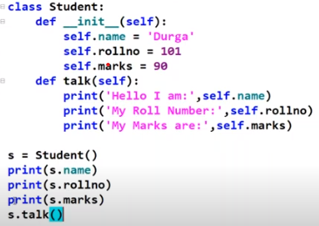

**Reference variable:** We can take many number of reference variable we can use for single object above program is ‘S’ reference variable

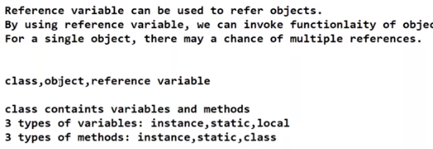

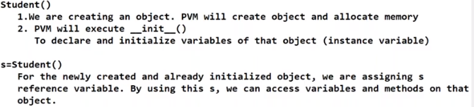

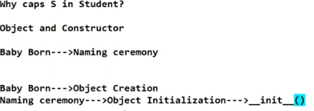

**Self**

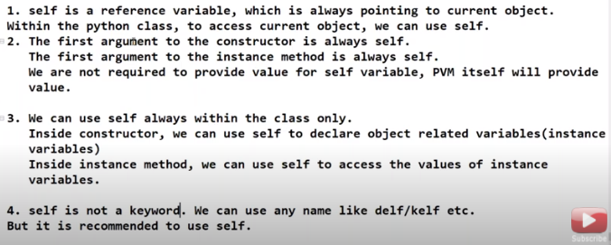**Constructor**

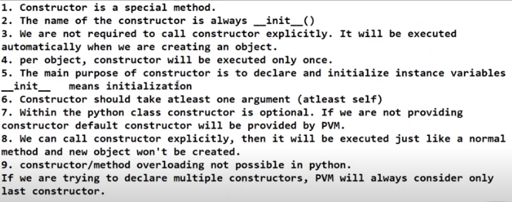

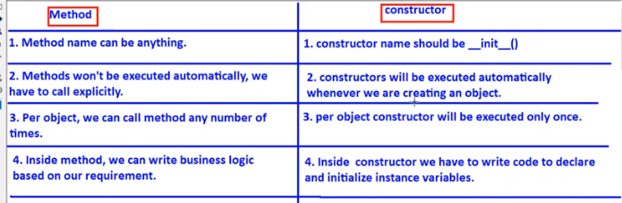

Note: Based on the above discussion we will go for develop mini application

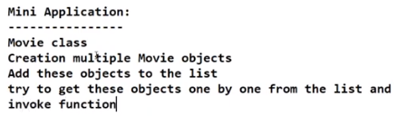

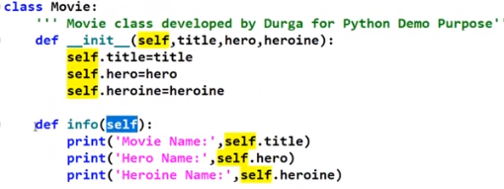

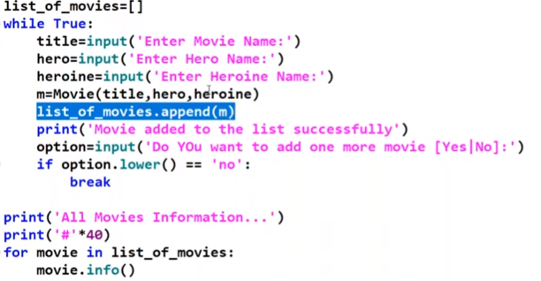**OUTPUT of the Above program with console**

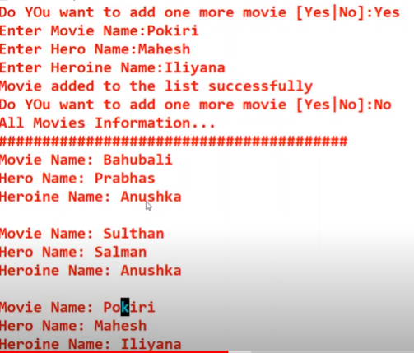

Types of variables: 1. Instance variable (Object level)

2.Static variable (Class Level)

3. Local Variable (Method level)

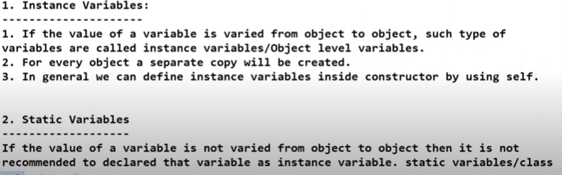

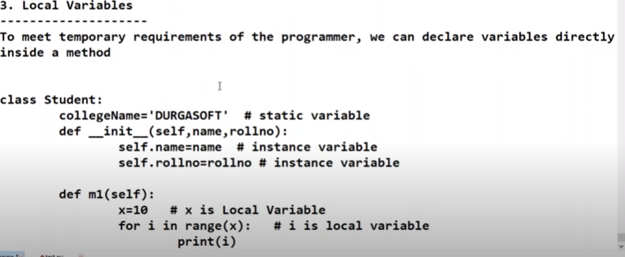

**Types of methods**

Types of methods: 1. Instance Method

2. Static method

3. Class method



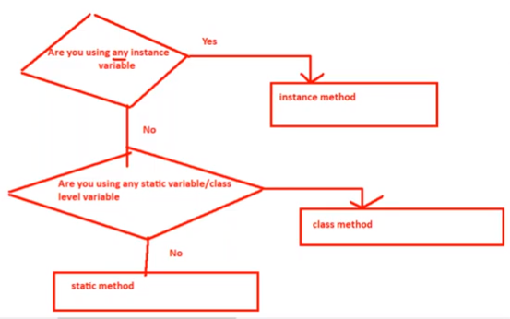

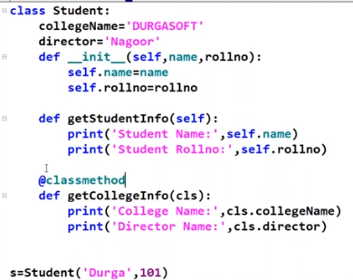

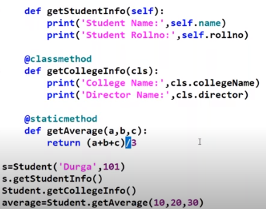

Note: Static method will call with class name not with object same as class method also.

